|  |  |
| --- | --- |
| [KAN-4] [The Tik Tok icon is not available for clicking](https://tmelnychok30.atlassian.net/browse/KAN-4) Created: 14/вер./24  Updated: 15/вер./24 | |
| **Status:** | To Do |
| **Project:** | [Pet-Project AI Guru](https://tmelnychok30.atlassian.net/secure/BrowseProject.jspa?id=10000) |
| **Components:** | None |
| **Affects versions:** | None |
| **Fix versions:** | None |

|  |  |  |  |
| --- | --- | --- | --- |
| **Type:** | Bug | **Priority:** | Medium |
| **Reporter:** | [Tetiana Melnychok](https://tmelnychok30.atlassian.net/secure/ViewProfile.jspa?accountId=712020%3A4e68e605-a434-4948-bfa8-bb53c39de0a3) | **Assignee:** | [Tetiana Melnychok](https://tmelnychok30.atlassian.net/secure/ViewProfile.jspa?accountId=712020%3A4e68e605-a434-4948-bfa8-bb53c39de0a3) |
| **Resolution:** | Unresolved | **Votes:** | 0 |
| **Labels:** | UI | | |
| **Remaining Estimate:** | Not Specified | | |
| **Time Spent:** | Not Specified | | |
| **Original estimate:** | Not Specified | | |

|  |  |
| --- | --- |
| **Attachments:** | Screenshot_1.png |
| **Issue links:** | |  |  |  |  | | --- | --- | --- | --- | | **Blocks** | | | | | blocks | [~~KAN-12~~](https://tmelnychok30.atlassian.net/browse/KAN-12) | Functional testing of the main page | Done | |
| **Rank:** | 0|i0000f: |
| **Flagged:** | Impediment |

|  |  |
| --- | --- |
| **Description** |  |

|  |
| --- |
| **Steps:** 1. Follow the link: <https://aiguru.com.ua/>; 2. Scrolled down the main page; 3. Click on the Tik Tok icon in the bottom right corner.  **Expected result:**  The icon is active; redirects to the Tik Tok channel.  **Actual result:**  It is impossible to click on the Tik Tok icon; the icon is blocked by another element of the website. |

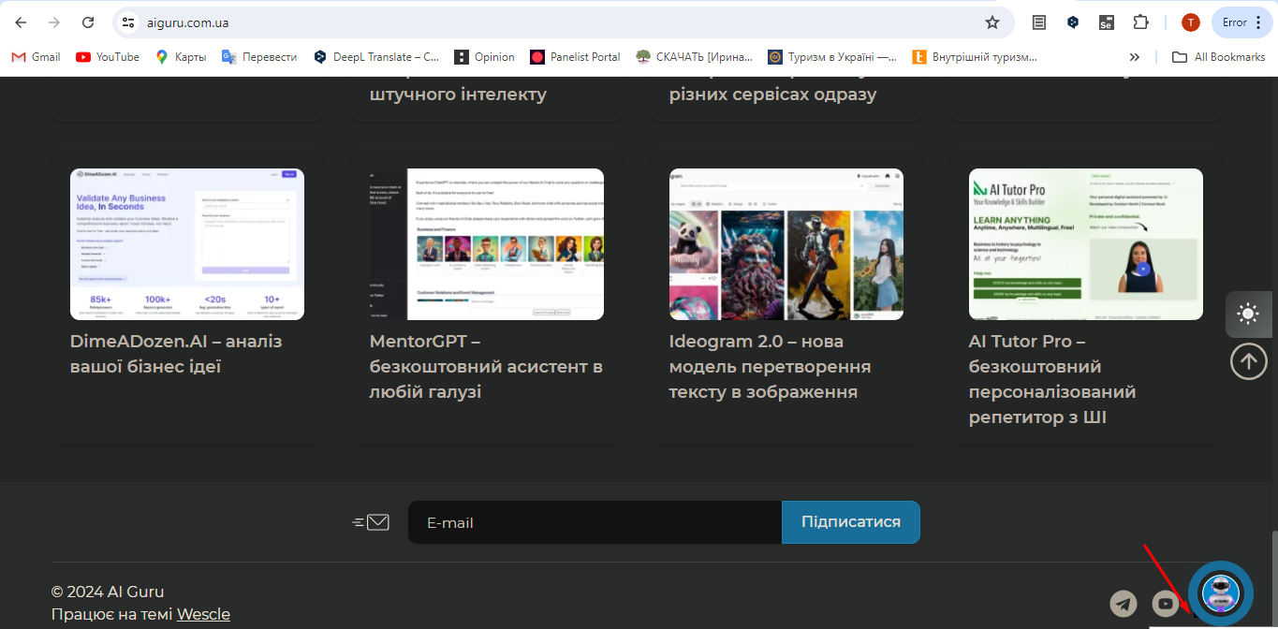

Generated at Wed Sep 18 10:02:23 UTC 2024 by Tetiana Melnychok using Jira 1001.0.0-SNAPSHOT#100266-rev:ad659bfedd37e84df77f3282f1ff9608fe72e5e4.